**SMART TEMPERATURE DETECTION SYSTEM**

A PROJECT PHASE-II REPORT

SUBMITTED BY

**SAURABH RAUT (BI048)**

**SUBHASH DEMUNDE (BI017)**

**DARPAN SETHI (BI015)**

**ROHITH PULLURI (BI045)**

UNDER THE GUIDANCE OF

**PROF. ANAND BHOSALE**

BE (INFORMATION TECHNOLOGY)



DEPARTMENT OF INFORMATION TECHNOLOGY

INTERNATIONAL INSTITUTE OF INFORMATION TECHNOLOGY,

SAVITRIBAI PHULE PUNE UNIVERSITY

HINJAWADI, PUNE (MH)-411057

MAY 2018

CERTIFICATE

DEPARTMENT OF INFORMATION TECHNOLOGY

INTERNATIONAL INSTITUTE OF INFORMATION TECHNOLOGY,

HINJAWADI, PUNE-411057

This is to certify that

**SAURABH RAUT (BI048)**

**SUBHASH DEMUNDE (BI017)**

**DARPAN SETHI (BI015)**

**ROHITH PULLURI (BI045)**

Class: BE (IT) have completed Project titled, ‘SMART TEMPERATURE DETECTION SYSTEM’ as a part of semester II of Final Year of Bachelor of Engineering in Information Technology (2017-2018) of Savitribai Phule Pune University.

Prof. Anand Bhosale Prof. Manjusha Amrutkar

Project Guide HOD (IT)

Place: Pune Seal

Date:

ABSTRACT

The system proposed in this report is an advanced solution for monitoring temperature at particular place which will raise an alert as soon as temperature goes beyond certain range. The technology behind this is cloud computing, Internet of Things which is an advanced and efficient solution for connecting the entire world of things in a network. The systems deals with monitoring and controlling environmental condition like temperature with sensors and send this information to cloud. The data updated from the current reading can be used to generate an e-alert if the temperature goes beyond certain limit. The proposed system may be used in the situation where fire can cause damage to the computers and may effect on user’s current work. This system may be useful in maintaining user’s integrity by automatically terminating the current transactions. Firebase real time database can be used to monitor the temperature conditions. Moreover, an alert message notification was implemented in Android application so that a user is notified whenever the temperature reading reaches the preset threshold. On the other hand, the smart chair system has brilliant commercial prospects, which can be helpful to build health care products with the help of wearable sensors, intelligent refrigerator/oven temperature tracking system and etc.

**INTRODUCTION**

Cloud computing which mainly consists of using others resources for our use has become an enabling technology eco-system with several application areas are Smart Home, weather forecasting, etc. Present innovations in technology mainly focus on controlling and monitoring of different activities. These are increasingly emerging to reach the human needs.

The data stored or processed by other can be accessed by cloud servers and can generate an e-alert message on entities like mobile, laptop, etc. connected to cloud using internet. Cloud service provider provides resources and services to upload, retrieve and visualize data received from various devices in cloud. Various applications are there to provide exciting features.

To add to these developing trends we are trying to improvise the existing cloud and IoT features in such a way that temperature can be monitored and an e-alarm can be generated. The monitoring of temperature is possible with temperature sensors and aruino-uno. This details or readings can be fetched by cloud servers and matched with the data readings and can be sent to each users connected to cloud service. Each user can view the current temperature reports and can rely on the systems in case of fire.

List of Figures:

**Chapter 1:**

**Introduction:**

Our project mainly comprises of one major technology in which we are working. It is described as follows.

* 1. **Cloud Computing**

Cloud computing is a general term for the delivery of hosted services over the internet. Cloud computing enables companies to consume a compute resource, such as a virtual machine ([VM](http://searchservervirtualization.techtarget.com/definition/virtual-machine)), storage or an application, as a utility -- just like electricity -- rather than having to build and maintain computing infrastructures in house. Cloud computing deployment models Cloud computing services can be private, public or hybrid.

1.2 **FIREBASE REAL TIME DATA MANAGEMENT:**

#### 1.2.1Firebase Cloud Messaging

Formerly known as Google Cloud Messaging (GCM), Firebase Cloud Messaging (FCM) is a cross-platform solution for messages and notifications for Android, iOS, and web applications, which currently can be used at no cost.

1.2.2 Real-time Database

Firebase provides a real-time database and backend as a service. The service provides application developers an API that allows application data to be synchronized across clients and stored on Firebase's cloud. The company provides client libraries that enable integration with android, iOS, JavaScript, Java, Objective-C, swift and Node.js applications. The database is also accessible through a REST API and bindings for several JavaScript frameworks such as AngularJS, React, Ember.js and Backbone.js. The REST API uses the Server-Sent Events protocol, which is an API for creating HTTP connections for receiving push notifications from a server. Developers using the real-time database can secure their data by using the company's server-side-enforced security rules. Cloud Fire store which is Firebase's next generation of the Real-time Database was released for beta use.

#### 1.2.3 Firebase Storage

Firebase Storage provides secure file uploads and downloads for Firebase apps, regardless of network quality. The developer can use it to store images, audio, video, or other user-generated content. Firebase Storage is backed by Google Cloud Storage.

#### 1.2.4 Firebase Hosting**[**[**edit**](https://en.wikipedia.org/w/index.php?title=Firebase&action=edit&section=10)**]**

Firebase Hosting is a static and dynamic [web hosting service](https://en.wikipedia.org/wiki/Web_hosting_service) that launched on May 13, 2014. It supports hosting static files such as [CSS](https://en.wikipedia.org/wiki/Cascading_Style_Sheets), [HTML](https://en.wikipedia.org/wiki/HTML), [JavaScript](https://en.wikipedia.org/wiki/JavaScript) and other files, as well as [dynamic Node.js support through Cloud Functions](https://firebase.google.com/docs/hosting/functions). The service delivers files over a [content delivery network](https://en.wikipedia.org/wiki/Content_delivery_network) (CDN) through [HTTP Secure](https://en.wikipedia.org/wiki/HTTP_Secure) (HTTPS) and [Secure Sockets Layer](https://en.wikipedia.org/wiki/Secure_Sockets_Layer) encryption (SSL). Firebase partners with Fastly, a CDN, to provide the CDN backing Firebase Hosting. The company states that Firebase Hosting grew out of customer requests; developers were using Firebase for its real-time database but needed a place to host their content.

Chapter 2

Literature Survey

We have referred following papers:

# Cloud of Things: Integrating Internet of Things and cloud computing and the issues involved

**OVERVIEW:**

Cloud computing and Internet of Things (IoT), two very different technologies, are both already part of our life. Their massive adoption and use is expected to increase further, making

them important components of the Future Internet. A novel

paradigm where Cloud and IoT are merged together is foreseen

as disruptive and an enabler of a large number of application

scenarios. In this paper we focus our attention on the integration

of Cloud and IoT, which we call the *CloudIoT* paradigm. Many

works in literature have surveyed Cloud and IoT separately:

their main properties, features, underlying technologies, and open

issues. However, to the best of our knowledge, these works

lack a detailed analysis of the CloudIoT paradigm. To bridge

this gap, in this paper we review the literature about the

integration of Cloud and IoT. We start analyzing and discussing

the need for integrating them, the challenges deriving from such

integration, and how these issues have been tackled in literature.

We then describe application scenarios that have been presented

in literature, as well as platforms – both commercial and open

source – and projects implementing the CloudIoT paradigm.

Finally, we identify open issues, main challenges and future

directions in this promising field.

Internet of Things-based Temperature Tracking

System

The work described in this paper consists of a temperature tracking system that follows a Client-Server architecture. A RaspberryPi, a System-on-a-Chip (SoC) device, is responsible for sensing the temperature and streaming it to a

server; the readings then are displayed in a mobile android

application. For this system, a python application was

developed to sense and stream the temperature, a servlet was

developed to read and store the temperature in a SQLite

database, and a mobile Android application was developed to

read and display the temperature readings from the server.

The initial versions of the project used the SoC device as a

server (storing temperature readings into a local SQLite

database), and both the SoC device and the mobile device

needed to be connected in a local area network. However, the

project was further developed to separate the server

responsibilities from the SoC device. The system now supports

user authentication, and both devices are connected through

the Internet. This implementation allows the temperature

readings to be viewed and displayed anytime from anywhere in

the world since the database is hosted on a server which can be

accessed over the internet. Also, this solution allows multiple

SoC devices to stream temperatures to the server, to different

mobile clients using the same database. The Android client

application was also implemented to graphically show the

temperature readings recorded by RaspberryPi using RESTful architecture. Moreover, an alert message notification was

implemented in Android application so that a user is notified

whenever the temperature reading reaches the preset

threshold. On the other hand, the smart chair system has

brilliant commercial prospects, which can be helpful to build

health care products with the help of wearable sensors,

intelligent refrigerator/oven temperature tracking system and

etc.

# Integration of Cloud Computing and Internet of Things

**OVERVIEW AND MOTIVATION:**

**PROPOSED METHADOLOGY:**

This project has been divided into several modules. These have been listed below.

1. **Temperature sensor captures the current temperature reading and uploads to cloud server:**

The temperature sensor will capture the current temperature readings. It will upload the current readings to cloud server after regular intervals. The cloud server will fetch the current readings of the temperature at the particular location.

1. **Real time data management using firebase:**

With the help of Amazon AWS a console can be build which will take the input readings check with the certain predefined readings and will be used to show the temperature readings to the user.

1. **Displaying current temperature on the portal:**

The current temperature readings will be made displayed on portal of the device connected to the cloud servers.

1. **Cloud sever will fetch the readings and match up with the boundary conditions:**

The cloud server will continuously check the updated readings with the boundary conditions set by system admin.

1. **Generation of an e-alert message:**

In case the temperature readings goes beyond certain range, there can be possibility of fire. In such case an e-alert message in the form of alert over portal and text message can be set in case device disconnected from the cloud server network.

1. **Sending the location of the fire affected place to nearest fire station.**

This stage mainly includes sending the coordinates of fire affected place to nearest fire station with the help of GPS of device.

1. **Respective action taken by Fire Station Admin:**

After getting an alert message from respective location fire station admin can take the subsequent action to control over the fire.

The alert to fire station admin can be in any form such as an email or sms message.

**Proposed System Overview:**

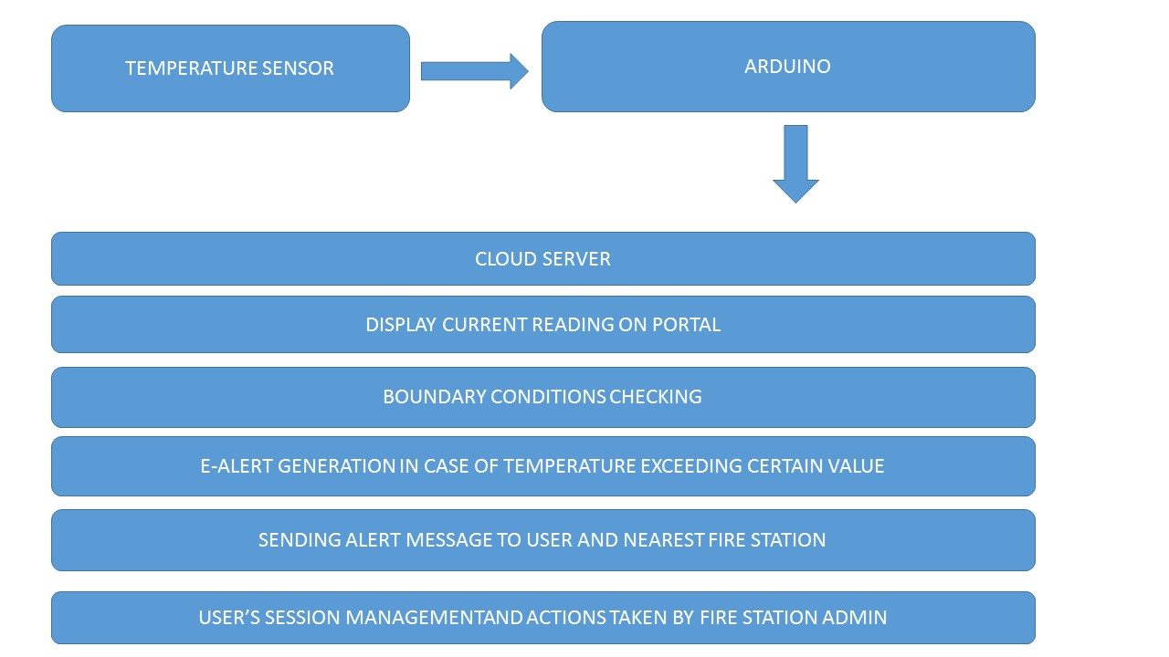

**Diagrams:**

* + - 1. **State Diagram:**

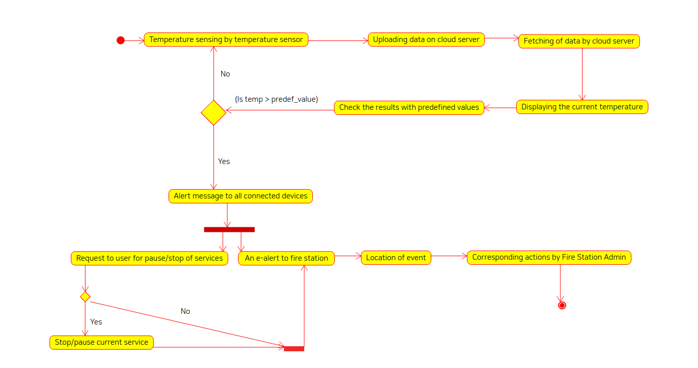

* + - 1. **Sequence diagram**

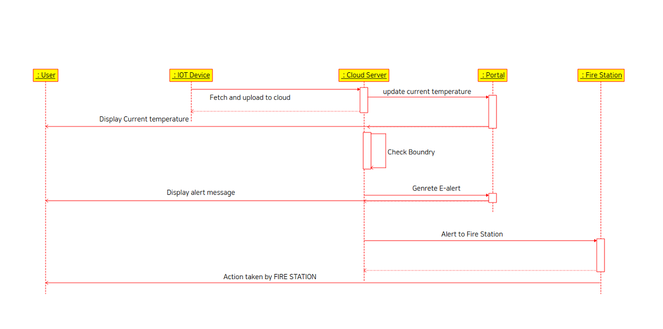

* + - 1. **Use case diagram**

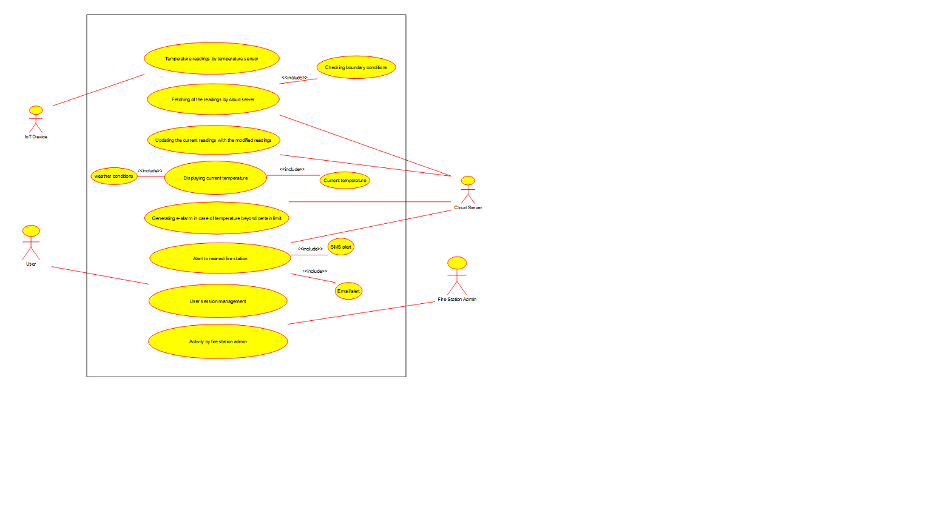

* + - 1. **Data Flow Diagram**

**Advancement and future work:**

A sms alert can also be sent to the respective user at the time of emergency while mobile network provider should be an integrated part of the project.

Also, live tracking of the fire extinguisher van can be enabled at the portal with the help of GPS.

User’s session management can also be controlled in case of handling sensitive data while having transactions, with prior permission of user auto disconnection can be implemented to maintain data integrity and consistency in transactions.

**Referances**

Yen-Kuang Chen, “Challenges and Opportunities of Internet of Things”, in the proceedings of 17th Asia and South Pacific Design Automation Conference, , 30 Jan. – 02 Feb., 2012, Santa Clara, CA, USA.

[2] Miao Wu et. al., “Research on the architecture of Internet of things”, in the proceedings of 3rd International Conference on Advanced Computer Theory and Engineering, 20-22 August, 2012,Beijing, China.

Shuai Zhang et. al., “Cloud Computing Research and Development Trend”, in the proceedings of International Conference on Future Networks, 22-24 Jan., 2010, Sanya, China.

CHAPTER

CONNECTION OF ESP 8266 WITH FIREBASE

1. SETTING UP ESP 8266

This stage mainly involves connecting Node MCU ESP8266 wifi module with LM 35 sensor. After connecting hardware with sensors following will enable the sensor to send the temperature readings over the internet.

1. FIREBASE MANAGEMENT CONSOLE
   1. CREATING A NEW PROJECT

A new project must be created in order to use firebase management console for our web app. After proper configurations use the toolbox to connect the firebase with our web app.

* 1. SETTING UP CONFIGURATIONS

To connect our web app to firebase a api key and auth-Domain is required.

This api-key is used as passkey to provide access real time database and authentication domain is mainly used for authentication purpose.

* 1. USING FIREBASE IN WEB

While integrating firebase with our web app can be done with your WiFi router name and password

#define WIFI_SSID "Wifi Router Name"  
#define WIFI_PASSWORD "Router Password"

* 1. UPDATING REAL TIME VALUE ON FIREBASE

Thus the real time value fetched by sensors will be get updated to firebase in the form of consecutive readings obtained over the period.

Timestamp is an important entity which will update the database value after a successful interval.

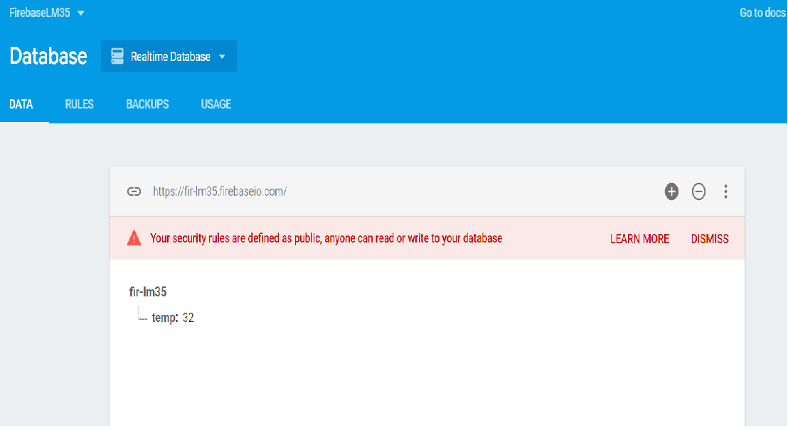

CHAPTER ---

SECURING USER’S DATA

Most the times a condition may arise that the damage caused by the fire may cause threat to the significant data stored in user’s system. Securing user data to local machine is not the feasible option. Smart Temperature detection system provides an option to secure user’s data by automatically uploading it to the cloud server in case of emergency.

CLOUDINARY MANAGEMENT CONSOLE

Cloudinary's Management Console provides valuable information about your images, powerful image browsing capabilities, reports, and various account customization options.

We have used cluoduinary as a cloud server .

DATA TYPES WITH CLOUDINARY MANAGEMENT:

In the initial stage only image format like .png and .jpeg are uploaded. Since the cloudinary platform is more user-friendly with images we tried to upload only image data types.

As the functionality of cloud server increases with the help of advance cloud servers such as Amazon AWS no of file types can be integrated.

CLOUDINARY MANAGEMENT DASHBOARD

Cloudinary management console provide a smart way to manage your images and personal fiels.

